Sainsmart Self-Balancing Robot Version 2.0

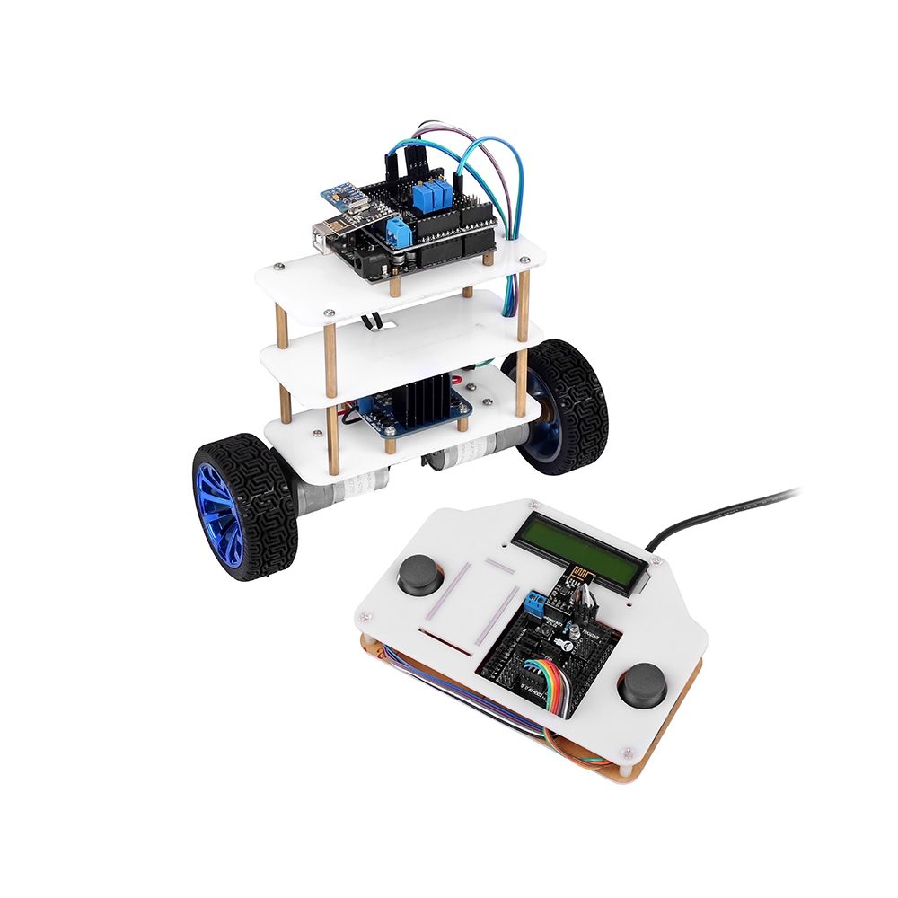

This was on sale at Microcenter ($49.14 marked down from $119.99), it appears to be a very old version of the robot - it comes with a remote control. The current version comes with bluetooth and a bluetooth app (I don’t think it would be that hard to add bluetooth or wifi to this version thou)

Resources are limited (since it’s 2 versions old at this point)

Here is what I found on the Sainsmart website:

(Appears to be a wiring diagram for the motors and shield included)

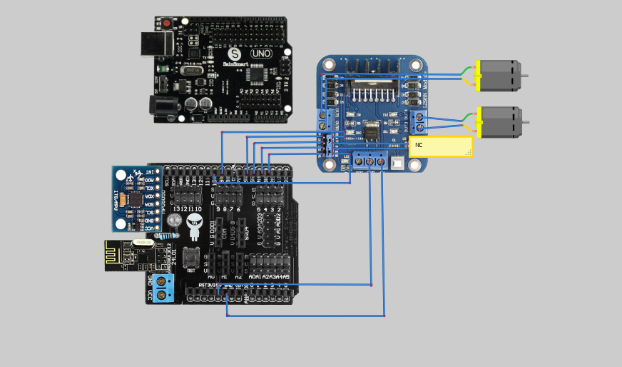

<http://wiki.sainsmart.com/index.php/101-20-103>

(The IDE listed on this wiki page is for Windows, and is a older IDE - it does however have a few example sketches for the robot that are not included in the documents)

Microcenters web page on the robot:

<http://www.microcenter.com/product/443978/InstaBots_Upright_Rover_Kit_V20_Updated_2-Wheel_Self-Balancing_Robot_Kit>

Other Information:

With our self balancing robot we aimed to create something that beginners and experts could both enjoy. We provide all the parts and easy-to-follow instructions, you provide the final result. The beauty of our self balancing robot is that it is totally customizable; it starts from our design but can become something totally your own. Add sensors, cameras or any other parts and pieces you can think of. Designed by our top product engineers and approved by beginner enthusiasts, the self balancing robot leaves no room for excuses.

## Specifications

**PRODUCT INFORMATION**

SKU

586636

Mfr Part#

20-011-403

UPC

811820021881

**GENERAL**

Motor Type

Stepper

Rotation

Continuous

Operating Voltage

10v ~ 13v

Communication

Arduino

Case Material

Plastic

Case Color

White

Gear Material

Plastic

Speed

No-Load: 400rpm

Weight

1.16 lbs.

What's in the Box

3 x Potentiometer, 2 x UNO R3, 2 x USB Cable, 2 x Sensor Shield, 2 x 24L01, 2 x Joystick, 2 x Gear Motor, 2 x Wheel, 2 x Motor bracket, 2 x Coupling, T-Plug, 9V Battery Snap, MPU6050, L298N, Balancing Robot Platform, Wireless Remote Controller Platform, Box, Wires, Connectors

